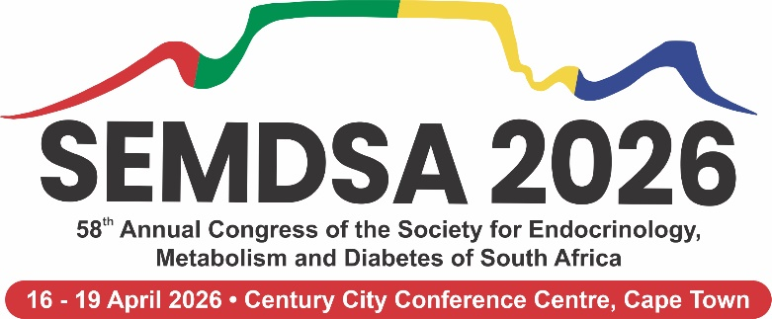
View Abstract Guidelines
Kindly complete the document below (highlighted in yellow), including the corresponding author (main contact person) as well as the information for all authors. Please update the file name as follows: SEMDSA 2026 – Presentation Format – Title Name Surname. Once completed, please email the document to elize@londocor.co.za.

Corresponding Author
Title, Name & Surname:
Email Address:
Country:
Contact Nr:
Profession:
Delete any unnecessary information and retain only the applicable details
Presentation Format: Oral Presentation / Poster Presentation
Category: Clinical: Endocrinology / Clinical: Diabetes / Basic Science / Other
Registrar: Yes / No
Consider for "Best Presentation" Award: Yes / No
Acknowledgement: I/we understand that if my/our abstract is accepted, I/we will not receive sponsorship from the organising committee to attend the congress. Furthermore, I/we confirm that I/we have read the Call for Abstracts and accept and understand all terms therein.
Biographical Sketch:
Write a short biographical sketch (100 words) about yourself in third person. This biography will be used for your introduction if your abstract us accepted.

ABSTRACT
Your Title Here
Author 1 Name Surname¹; Author 2 Name Surname²; Author 3 Name Surname³; Author 4 Name Surname⁴; Author 5 Name Surname⁵; Author 6 Name Surname⁶; Author 7 Name Surname⁷
¹Institute, Affiliation
²Institute, Affiliation
³Institute, Affiliation
⁴Institute, Affiliation
⁵Institute, Affiliation
⁶Institute, Affiliation
⁷Institute, Affiliation
Background:
Your background here.
Methods:
Your methods here.
Results:
Your results here.
Conclusion:
Your conclusion here.

Author 1 Information:  Title, Name & Surname:  Email Address:  Contact Nr:  Profession:  Institute/Affiliation:  Country: | Author 2 Information:  Title, Name & Surname:  Email Address:  Contact Nr:  Profession:  Institute/Affiliation:  Country: | Author 3 Information:  Title, Name & Surname:  Email Address:  Contact Nr:  Profession:  Institute/Affiliation:  Country:
Author 4 Information:  Title, Name & Surname:  Email Address:  Contact Nr:  Profession:  Institute/Affiliation:  Country: | Author 5 Information:  Title, Name & Surname:  Email Address:  Contact Nr:  Profession:  Institute/Affiliation:  Country: | Author 6 Information:  Title, Name & Surname:  Email Address:  Contact Nr:  Profession:  Institute/Affiliation:  Country:
Author 7 Information:
Title, Name & Surname:
Email Address:
Contact Nr:
Profession:
Institute/Affiliation:
Country:

